CIE 2 : Arduino with LCD and Temperature Sensor

Aim : To interface an LCD display and a temperature sensor (such as LM35 or DHT11) with an Arduino to display real-time temperature readings.

Overview :
This project demonstrates how an Arduino microcontroller can read temperature data from a sensor and display it on an LCD screen. It helps in understanding sensor interfacing, analog-to-digital conversion, and real-time data visualization using an LCD.

Materials Required :
- Arduino Uno R3
- LCD 16x2
- 3 x 1kΩ Resistor
- Temperature Sensor (TMP36)
- Piezo Buzzer
- Jumper Wires
- Arduino IDE (Installed on your Computer)

Circuit Connection and Steps :
- Connect LCD (16x2) with I2C to Arduino:
- VCC → 5V, GND → GND
- SDA → A4, SCL → A5

Connect Temperature Sensor (LM35) to Arduino :
- VCC → 5V, GND → GND, OUT → A0

If Using DHT11 Instead of LM35 :
- VCC → 5V, GND → GND, Data → D2 (Use 10kΩ pull-up resistor if needed)

Set Up Arduino IDE :
- Open Arduino IDE
- Install "LiquidCrystal_I2C" and "DHT sensor" libraries (if needed)
- Select the correct board and port
- Upload the code and observe temperature readings on LCD
Circuit Diagram :
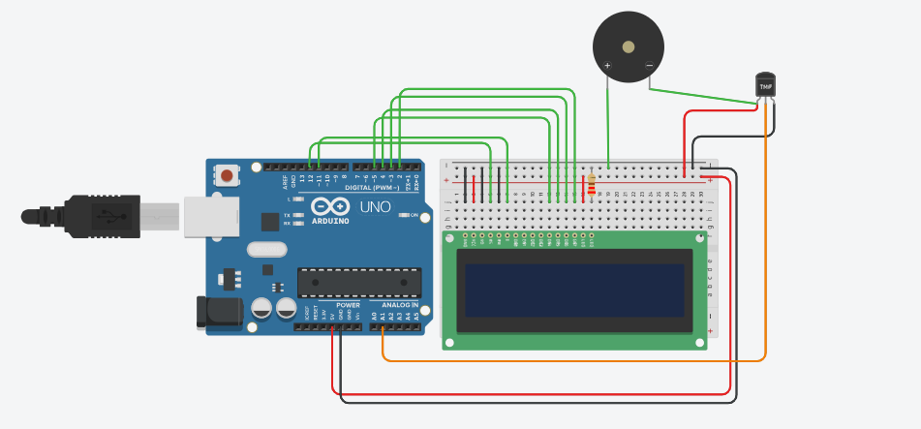
Schematic Diagram :
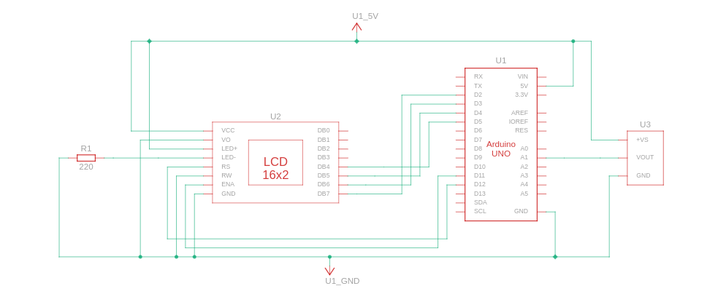

Code :
#include <LiquidCrystal.h>

// Define LCD pin connections
const int RS = 12, EN = 11, D4 = 5, D5 = 4, D6 = 3, D7 = 2;
LiquidCrystal lcd(RS, EN, D4, D5, D6, D7);

// Temperature sensor pin
const int TEMP_SENSOR = A1;

void setup() {
lcd.begin(16, 2); // Initialize LCD (16x2 display)
pinMode(TEMP_SENSOR, INPUT);
}

void loop() {
// Read temperature sensor value
float voltage = analogRead(TEMP_SENSOR) * (5.0 / 1023.0);
float temperature = (voltage - 0.5) * 100.0;

// Display temperature on LCD
lcd.setCursor(0, 0);
lcd.print("Temperature:");

lcd.setCursor(0, 1);
lcd.print(temperature);
lcd.print(" C");

delay(1000); // Update every second
lcd.clear();
}

Results :
The LCD screen will display real-time temperature readings.
- The temperature sensor will measure the surrounding temperature and send the data to the Arduino.
- The LCD will update every 1 second, showing the current temperature in Celsius.
- If the temperature changes, the display will reflect the new value dynamically.
- This cycle will repeat indefinitely, continuously monitoring and displaying temperature readings.

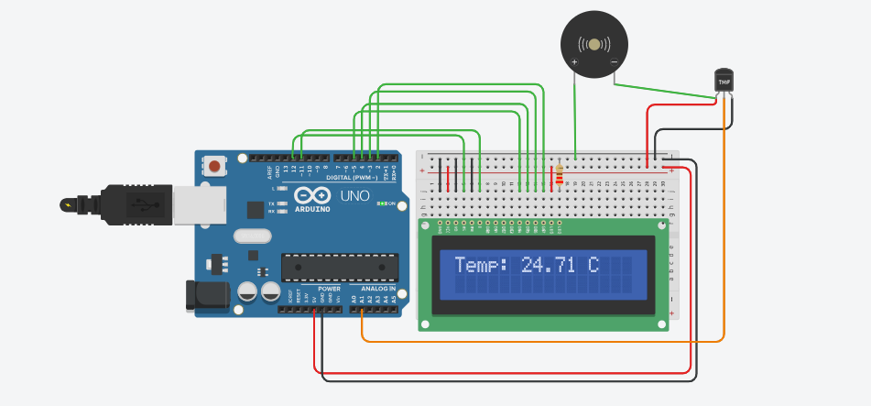

Conclusion :
This project successfully interfaces an LCD and a temperature sensor with an Arduino. It provides practical experience with sensor integration, data display and I2C communication. It can be extended for real-time temperature monitoring in smart home systems.

